RADM Roy Francis Hoffmann USN (Ret)
November 18, 1925 - November 8, 2022
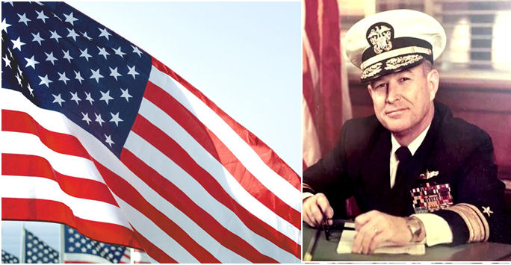

Rear Admiral Roy Francis Hoffmann, passed away on November 8, 2022, in Midlothian, Virginia. He was born in St. Louis, Mo., on November 18, 1925. He was preceded in death by his parents, Roy W. Hoffmann and Zettamae Pruneau Hoffmann; and sisters, Juanita Wyatt and Donna Hoffmann.

Admiral Hoffmann is survived by his extraordinary wife of 72 years, Mary Linn Thompson Hoffmann, Midlothian, Va.; and brother, Paul I. Hoffmann, St. Louis, Mo.; five daughters, Harriet Hoffmann, Richmond, Va., Christine Carnahan, Durham, N.C., Cecile Gorham (Peter), Charlottesville, Va., Hilarie Hanson (Jack), Poulsbo, Wash., and Emilie Crow (Rory), Geronimo, Okla.; seven grandchildren, Erin Lane, Seth Gorham, Kalin Soper, Kelsey Hanson, John Hanson, Todd Gorham and Brooke Bass; two great-grandchildren, Aidan Lane and Emerson Lane.

Admiral Hoffmann was a highly decorated veteran of WWII, Korea and Viet Nam. He had command of four surface ships over his 35 year naval career, and was widely regarded as one of the best ship handlers in the U.S. Navy. After his Naval retirement, Admiral Hoffmann served as Port Director, Milwaukee, Wisconsin and Executive VP and COO, Meehan Overseas Terminal, Richmond, Va.

In addition to his successful career as a naval officer and businessman, Admiral Hoffmann spent hours in his workshop which was filled with machinery, tools and gadgets - a quintessential Mr. Fix-it. He was a skilled carpenter and built furniture, cabinetry and even a greenhouse for Mary Linn. His creations were built to the highest standards and will long be treasured by his family. Roy also loved and appreciated music, enjoying everything from Patsy Cline to John Phillip Sousa. Neighbors and family members fondly remember him singing and whistling as he worked in his shop or tinkered with the family cars.

The seas have finally calmed, Admiral. Rest easy, knowing that you will be in the hearts and minds of your loving family, friends and shipmates, for the rest of our days.

Admiral Hoffmann’s memorial service and burial will take place at Arlington National Cemetery with full military honors at a later date.

A native of Crystal City, Missouri, he enlisted in the Naval Reserve on April 28, 1943 and was commissioned from the University of Notre Dame NROTC Unit of 1 on June 1946. He advanced through the ranks to Rear Admiral on 1 July 1974.
Rear Admiral Hoffmann (RADM) served on eight ships during his sea service career. His initial assignment was on USS Quick DMS-32 which operated in the Western Pacific during the years 1946/1947. After a brief interruption of service, he reported aboard USS Pirate AM-275 on August 1950. While minesweeping off the shore of Wonson, Korea, Pirate hit a mine and sank in five minutes. The Admiral received the Purple Heart Medal for wounds he received during that enemy action. Returning to sea duty in December 1950, RADM Hoffmann reported aboard USS Harry E. Hubbard DD-748 as Gunnery Officer and again participated in several deployments through the remainder of the Korean hostilities. From July 1953 to August 1955 he served as an instructor in naval weapons at the NROTC Unit at Illinois Institute of Technology in Chicago.
In September 1955, RADM Hoffmann returned to sea duty as Aide and Flag Secretary to Commander Destroyer Flotilla TWO and subsequently as Executive Officer of USS Lloyd Thomas DDE-764, a ship that was employed primarily as an anti-submarine unit in Atlantic Fleet ASW operations.
In August 1959, RADM Hoffmann was ordered to duty in the Bureau of Naval Personnel as a Destroyer Placement Officer for the Atlantic Fleet. In July 1961, he assumed the first of four ship commands when he reported aboard USS Cromwell DE-1014. During his tour of command, CROMWELL joined ships of South American Navies in Anti-submarine Training in Exercise UNITAS II.
After completing two tours at the Naval War College in November 1965, RADM Hoffmann assumed command of the Atlantic Fleet Missile Destroyer Charles F. Adams DDG-2 and remained in command for 27 months. In May 1968, he reported for duty as Commander Coastal Surveillance Force (TASK FORCE 115). As вЂњMarket TimeвЂќ Commander, RADM Hoffmann was responsible for coastal security, harbor defense and inshore raider operations for the Republic of Vietnam. He was one of several senior officers instrumental in the original concept, planning, organization and execution of the highly successful operation SEALORDS. This was a joint and combined naval operations that initiated maximum integration of the Vietnamese Navy and Marine Corps with the United States Armed Forces. RADM Hoffmann was awarded the Distinguished Service Medal for exceptionally meritorious service against the Viet Cong enemy, the Silver Star Medal, and three Bronze Star Medals for conspicuous gallantry in action while Commander Task Force 115.
In June 1969, RADM Hoffmann assumed command USS Sierra AD-18, an Atlantic Fleet Destroyer Tender. In recognition of his leadership and SIERRAвЂ™S abilities to support the fleet during his command tour, RADM Hoffmann was awarded the Meritorious Service and Navy Commendation Medals. In February 1971, he assumed command of the Guided Missile Frigate USS Leahy DLG-16, a ship which achieved a reputation of continued excellence during his tour as Commanding Officer. LEAHY was awarded the Atlantic Fleet Anti-air Warfare Excellence for 1972. For his inspirational leadership as Commanding Officer, RADM Hoffmann was awarded a Gold Star in lieu of a second Meritorious Service Medal.
RADM Hoffmann detached from LEAHY in September 1972 and reported to the Office of the Chief of Naval Operations as Head, Current Plans Branch, and upon selection for Rear Admiral in 1973, he assumed duties as Director Surface Warfare Division.
In November1974, RADM Hoffmann relieved as Commander Mine Warfare Workforce in Charleston, SC. When the type command was disestablished in July 1975, he became the Commander of the newly organized Mine Warfare Command, with direct responsibility to the Chief of Naval Operations and the Fleet Commanders for all matters concerning mine warfare.
In June 1976, he assumed the additional duties of Commandant, SIXTH NAVAL DISTRICT/COMMANDER NAVAL BASE CHARLESTON. In 1976, he assumed duties as COMNAVBASE Charleston/COMSIX upon being relieved as COMINEWARCOM.
RADM Hoffmann retired on 1 September 1978 ending a career spanning 35 years and three wars.
In addition to the personal decorations referred to above, RADM Hoffmann wears the Legion of Merit with gold star in lieu of second award, Navy Commendation Medal, Presidential Unit Citation and Vietnamese Navy Distinguished Service Order Second Class Medal. His Campaign and Service Medals are: American Campaign, China Service, Navy Occupation (Japan), World War II Victory, National Defense with one star, Korean Service with seven stars, Korean Presidential Citation, United Nations, Vietnam Service with four stars, Vietnam Campaign and Navy Expeditionary (Cuba). RADM Hoffmann holds a BS in chemistry from the University of Nebraska and an MS in International Affairs from George Washington University.

https://www.blileys.com/obituaries/RADM-Roy-Francis-Hoffmann-USN-Ret?obId=26344252#/obituaryInfo

