OBITUARY

Captain Walter W. Salmon Jr. (USN-RET)

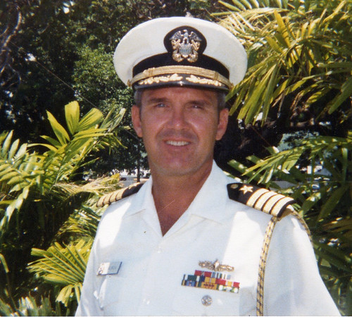 |  | 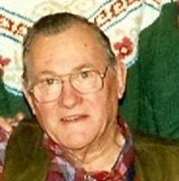

April 17, 1934 – August 7, 2015 (81 years old)
On August 7, 2015, Captain Walter W. Salmon, Jr. (USN-RET); beloved husband of Joan W. Salmon (nee Waterfield); cherished father of Scott Keyser, Lynn Tierney and her husband Bruce, Barbara Phillips and her husband Kevin, and Bradley Salmon and his wife Mary; loving grandfather of Julia and Lauren Tierney; dear brother of Rev. Doctor Alan K. Salmon.
Service to be held at Trinity Church Moorestown, NJ, on Friday, August 14, 2015 at 10:30AM. Memorial Contributions may be made to Episcopal Relief and Development thru Church of the Redeemer, Charles Street, Baltimore, MD 21210, or St. Paul's Episcopal Church, 188 S. Swinton Avenue, Delray Beach, FL 33444. Arrangements by Schimunek Funeral Home, 9705 Belair Road, Nottingham. www.schimunekfuneralhomes.com
https://www.dignitymemorial.com/obituaries/nottingham-md/captain-walter-salmon-6546833

Full Military Honors for Captain Walter William Salmon, Jr. at Arlington Cemetery on Monday, May 16, 2016.
Ceremony was celebrated by his wife Joan Salmon, his brother Alan, and many close friends.
https://djwhip.smugmug.com/Captain-Walter-William-Salmon-/Full-Military-Honors-for-Capta/

