In Memory of—
Wayne Jeffrey Askew 1959 - 2019

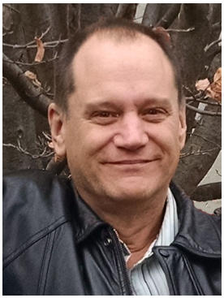

Wayne Askew of Willseyville, formerly of Grand Island, NY, went Home to be with The Lord on Wednesday, January 30th, 2019, after a courageous battle with cancer. He passed away at home with his loving family present with him. He was predeceased by his parents, William and Carole (Shea) Askew, and son, Adam Askew. He is survived by his wife, Maria (“Mary”) Askew and son Kyle Askew, both of Willseyville, NY. Other surviving family include his siblings Susan Axtell of Gwinn, MI, Diane (Joseph) Scalzi of St. Clair Shores, MI, William Askew, Jr., of Melbourne Beach, FL, Barbara Titterington of Newfield, NY and their families. Wayne was born in Buffalo, NY. He joined the Navy as a young man, the third generation of his family serving our country at sea. After leaving the service, he became a historic home restoration specialist and later served as a fierce advocate for lead poisoning awareness. Wayne was a light in this world, always doing his best to help others in any way that he could. He will be missed dearly. The family will receive friends Saturday, February 2, 2019 from 10:00 a.m. to 11:45 a.m. at St. Mark’s Episcopal Church, 17 Main St., Candor, NY with a funeral mass following at 12:00 Noon. Interment will follow in the spring, where Wayne will be laid to rest next to his son, Adam, at the Smith Valley Cemetery. In lieu of flowers, donations in Wayne’s memory can be made to the Candor Food Pantry, Guthrie Cancer Center, or St. Mark’s Episcopal Church. Condolences may be made to Wayne’s family at www.emfaheyfuneralhome.com.

Photo provided by Maria Askew | 