Captain William (Bill) H. Smith, USN (Ret.)
CO of USS Leahy 24 November 1991 - 19 June 1993
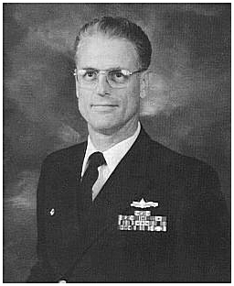
Captain William (Bill) H. Smith, the second to the last CO of USS Leahy (24 November 1991 - 19 June 1993), passed away 10 February 2021 after a battle with cancer. In his last years he moved from San Diego and settled in South Burlington, Vermont. He is survived by his wife Susan, son and daughter. He was cremated and there will be a memorial service and internment at the US Naval Academy on 13 August 2021. The attendance for this service might be very limited due to COVID.
Info above provided by:
-CDR Mark Jaszkowski, USN (Ret)
Bill's XO and the last Leahy CO.
-Captain Chris Paddock, USN (Ret).
LEAHY’s SUPPO 90-92 (under Captains West and Smith)

Additional Bio Info From WESTPAC Cruise Book 1992-1993
http://www.ussleahy.com/Bio/WHS.htm

