U.S.S. LEAHY DLG 16
AGENDA
BRANSON, MO
SEPTEMBER 15-18, 2014
THIRD CREW REUNION

SHIP SERVICE PERIOD AS

DESTROYER LEADER GUIDER MISSILE FRIGATE
4 AUGUST 1962 to 18 FEBRUARY 1967
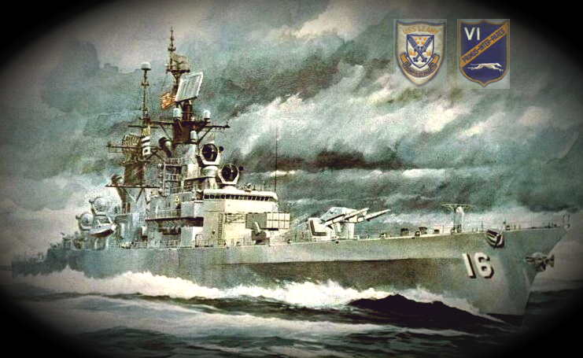
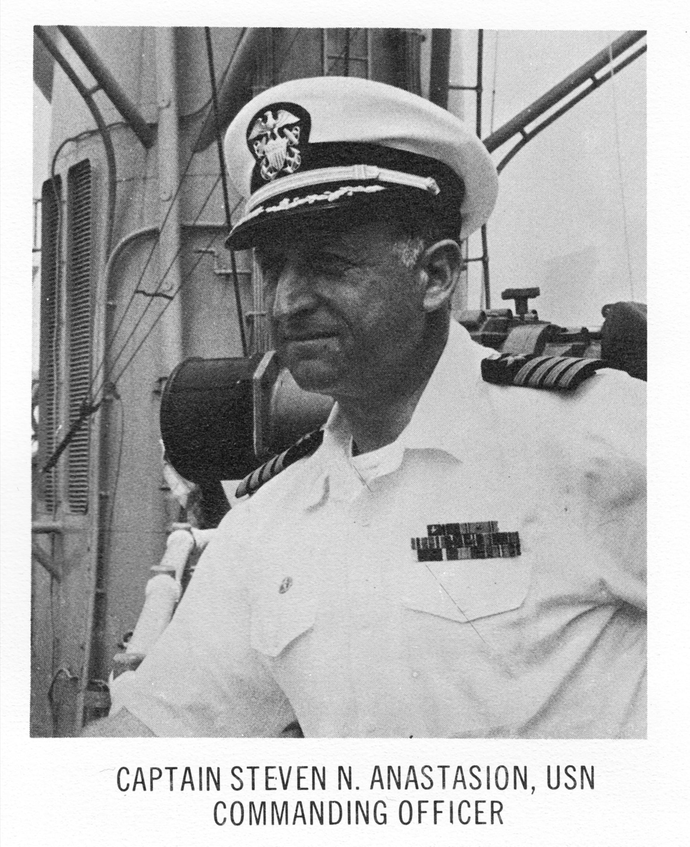
1964 1967

WELCOME ABOARD!

“ENJOY THE CRUISE DOWN MEMORY LANE WITH NEW AND OLD SHIPEMATES”

Monday, 15 September 2014
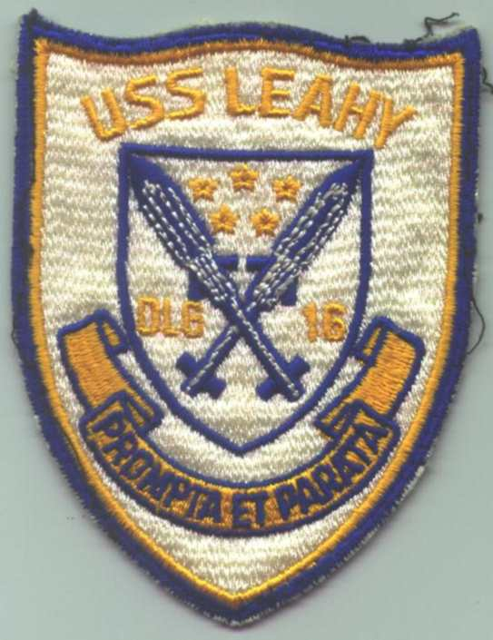
NOTE: Clarion Hotel located at 2820 West Highway 76, Branson, MO.

1400: Check-In time at Clarion Hotel, Branson, MO.

1600: Meet and Greet in the Buckingham’s Jungle Room located on the Cabana Level. Finger Snacks, drinks, and fellowship.

Tuesday, 16 SEPTEMBER 16, 2014

0700 – 0900: Chow Time (Breakfast) at SADIE’S (be sure have your coupons to eat) located out the front door and to the left short walking distance.

0930 – 1030: Crew meeting to discuss future of the reunion.

0930 – 1430: Linda Jeffries is setting possible shopping trip for the women.

Lunch and Afternoon: On your own to tour Branson

2000: Doug Gabriel #1 Hits Tribute Show – either meet at the theater or meet in hotel lobby

Wednesday, 17 SEPTEMBER 2014

0700 – 0900: Chow Time (Breakfast) at Sadie’s.

0930: Memorial Service for all Departed shipmates from Commissioning (August, 1962 thru February 18, 1967) will be held at the hotel.
“We must never forget them.”

After service you are free to explore Branson or relax in the Buckingham’s Jungle Room or the pool.

1900-Until: Farewell and acknowledgement dinner at the hotel in our meeting room.

THURSDAY, 18 September 2014

0700-0900: Farewell Breakfast at Sadie’s

1100: Checkout from Clarion Hotel

Parting Remarks:

May your seas be smooth
And your sails be full

May your journey home be safe
And till we meet again
May the Lord keep you safe
In the palm of His hand!

